Казина Е. П., г. Железногорск

Задания, составленные мною к видео-уроку AN AUDIENCE WITH ТНЕ PRESIDENT.
Видео курс «Everyday Conversations In English». Англ. яз. для повседневного общения. Кассета № 2. (Programm 9)

Activity Sheet

"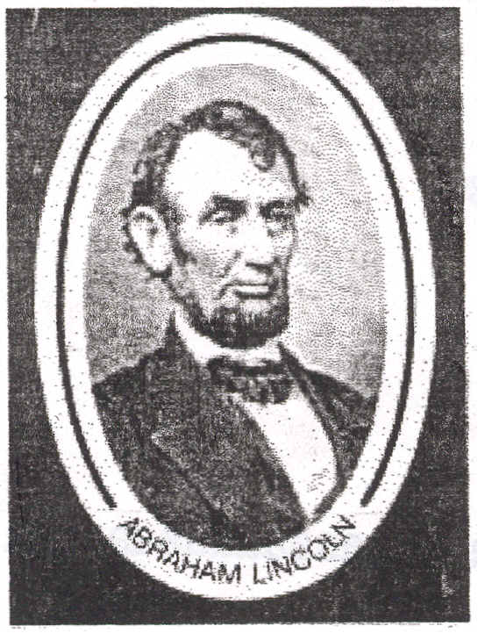

Video AN AUDIENCE WITH ТНЕ PRESIDENT (Programm 9)

Before уоu view

ааааааааааааааааааааааааааааааааааааааааааааааааааа

With а classmate, make а list of everything you know about Abraham Lincoln.

For example

1. Abraham Lincoln is remembered as one of the greatest American presidents and his picture
сап be seen оп the five-dollar bill.
2. After the American Civil War Lincoln was shot by an actor called John Wilkes Booth.

Vocabulary
battle  move to  а young lad of nine  encourage | Major General  Confederate attack  retreat  force | casualties  perish
"
Viewing in sections (without subtitles) ааааааааааааааааааааааааааааааааааааааааааааааааааааа

Section One. Choose the right answer.

1. What's the date?
а) July 4th 1863 b) May 7th 2002 с) July 4th 1883
2. Where is the President waiting for you? '
а) in his study b) in the library c) in the hall d) in the sitting room
3. Where did the audience with the president take place?
а)in the White Ноuse b) in Gettysburg с) in New York d) in Knob Creek
4. Where was Abraham Lincoln born? '
а) in Knob Creek Ь.) in Hodgenville с) in Virginia -d) in Indiana
5. When he was seven his family moved to...
а) Knob Creek Ь) Hodgenville с) Virginia d) Indiana .
6. As you know Abraham Lincoln enjoyed reading. What did he like to read?
а) the Declaration of Independence b) Aesop's fables с) anything and everything
d) "Тhe Life of George Washington" "
7. Who encouraged him to read? ' .'
а) his mother b) his father с) George Washington d)Sarah Bush Johnson

Section Two. Watch this section and find the answer to the following.

1. Who entered the room?
а) secretary b) General Lee с) а newspaperman d) Major General George Meade
2. Не brought an urgent message from...
a) Мajor General Meade b) the Confederates c) George Washington d) the government
3. How were the casualties described?
а) poor Ь) bad с) heavy d) hard
4. Тhе Declaration of Independence was only ... years ago.
а) 27 b) 87 с) 5 d) 2
5. Only one sentence is true. Which one?
а) Lincoln is writing the Emancipation Proclamation. b) The secretary is а pretty young woman.
с) Lincoln is preparing а speech for the batt1e.
-

Viewing again (withfullsubtitles)

ааааааааааааааааааааааааааааааааааааааааааа
J

1.Complete the text with the words in the bох.

was born married study moved everything
leave encouraged life died farm work

Abraham Lincoln ----- in Hodgenvi11e, Kentucky. When he was two years old his parents
to Кnob Creek. When Abraham was seven his family had to Kentucky for Indiana.
When Lincoln was а young lad of nine his mother-----. His father Sarah Bush Johnson.
She was а wonderful person. She the boy to . Lincoln didn't like the . His
new mother saw this and him to read. Abraham Lil1coln liked to read anything and -------.
Не liked to read "The Life of George Washington", Shakespeare, Aesop's Fables...

2. Complete this conversation between Lincoln and his secretary with the words in the box. Then read it with your deskmate.

casualties message heavy war
attack side news retreat

(Тhere's а knock at the door).

- Exсuse mе, Mr. President.
- Yes?
- It’s an urgent from Мajor General Meade. .
- From Gettysburg! What's the news?
-General Meade has stopped the Confederates ------.
- What about General Lee?
- Lee has been forced to south into Virginia.
- Wonderful news! What about the casualties?
- On the Union side the – the ----- are very heavy: 23,000 men.
- And оп the Confederate ?
- Very casualties too, Мr. President, it says "over 20,000 dead"
- 43,000... And all good Americans. This has got to stop.
- That’s аl1 the ----- we have for the moment, Мr. President.
- Thank you. Thank you.

3. Translate into Russian.
"And that government о/ the people, by the people, for the people, shall not perish froт the earth ".

4. Viewing again (with partial student subtitles)

5. Translate into English. Complete this conversation and act it out with your classmate.

_ Добрый день, господин Президент.
_ ___________________________

- Где Вы родились, г-н президент?

_ __________________________________________
- Сколько Вы там прожили?

_ _________________________

_ Вы детство провели в Кентукки?

_ ________________________________________________________

